Project Report

|  |  |
| --- | --- |
| **Course Name (NICF)** | NICF Diploma in Infocomm Technology (Data) |
| Product Name (Marketing & Sales) | Professional Diploma in Data Science |
| **Module Name (NICF)** | NICF Basic R Programming (SF) |
| Product Name (Marketing & Sales) | Basic R Programming |

|  |  |  |  |
| --- | --- | --- | --- |
| Student name | | Assessor name | |
| Syed Shabana | |  | |
| Date issued | Completion date | | Submitted on |
|  |  | |  |
|  | |  | |
| Project title | Design and deploy Forecasting Model | | |

|  |
| --- |
| Learner declaration |
| I certify that the work submitted for this assignment is my own and research sources are fully acknowledged.  Student signature: Date: |

Content

1. Project Overview 1
2. Project Technical Environment 2
3. Forecasting Model 3
4. Setting up the Forecasting Model 4
5. R Code for Data Filtering and Transformation
6. Transformed Data 6
7. Correlation Analysis Process and Output 7
8. Implementing Seasonal Forecasting Model 8
9. Refine Model 9
10. Forecast Output after Model Adjustment: 10
11. Project Overview:

* This project consists of California dairy production and pricing data. The main objective for this data is how the California milk production changes are predicted based on time series data.
* Forecasting is a widely employed and quite useful analytical method. Common uses range from predicting sales of seasonal items, determining optimal inventory levels, to predicting macroeconomic variables. Forecasting is typically done with time series models.
* This data includes monthly information on the production of several dairy products and the price of milk fat, a benchmark commodity. This dataset is an example of time-series data. Time series data is data in which the values have a time index. The time index can be regular, e.g. every month or every minute, or irregular. A time series model is based on time series data.
* I am using caddairydatav3_shabana.csv file for this project which consists of dairy production information published by the United States Department of Agriculture. The data set contains a time series of dairy production data for several products, along with milk fat pricing, for 128 months.
* This forecasting model will have two components, a trend component and a seasonal component. Here I am using Azure ML and R script to develop the algorithm and Linear Regression model.
* The Azure ML experiment illustrates the basics of building and evaluating a regression forecasting machine learning model, using Azure Machine Learning and R / Python .
* The goal of this experiment is to forecast the monthly milk production for the State of California. The R programming language contains flexible framework and extensive analytics for time series data.
* Here in this project I am working with Production and pricing data of a Diary. This data includes monthly information on the production of several dairy products and the price of milk fat, a benchmark commodity.
* Using R & Time-series model on Microsoft Azure ML, created a forecasting model for milk production from the data which includes monthly information on the production of several dairy products and the price of milk Model and results.
* A linear regression model for both the trend and seasonal variation is used. We are modelling seasonal variation as a monthly category (factor). Including an intercept term would make the problem over determined.
* Both the Evaluate Model module and custom code in an Execute R Script module measure model performance. An evaluation Execute R Script module outputs RMS error figures for the entire time series and for the 12 months used to test forecasting accuracy. As one would expect, the RMS error for the forecasted months is slightly greater than for the overall series. The evaluation Execute R Script module also produces several useful charts for evaluating the model.
* Overall, the fit to both trend and seasonal change are good. The model residuals (errors) are close to normally distributed with only a few outliers. Further, there is no particular trend and structure to these residuals with time.

1. Project Technical Environment:
2. Azure Machine Learning is a separate and modernized service that delivers a complete data science platform. It supports both code-first and low-code experiences. Azure Machine Learning Service allows us to prep, train, and test our data. We can deploy, manage, and track Machine Learning models starting from our local machines and then shifting to cloud without any hassle.

Azure Machine Learning studio is a web portal in Azure Machine Learning that contains low- code and no-code options for project authoring and asset management. Azure ML Studio uses a drag- and-drop feature which does not need any coding. There are predefined algorithms and sample datasets that we can work with.

# Azure ML Studio uses a drag-and-drop feature which does not need any coding. There are predefined algorithms and sample datasets that we can work with. If we want to predict value, we can use regression. We can forecast the future by estimating the relationship between variables. In this project we are using the linear regression algorithm.

# The following diagram illustrates the flow of Azure Machine Learning model.

* Import Data: In AML we first Import data that we need to evaluate.
* Data Transformation Mode: After importing data, we preprocess data like clean missing values or columns, remove outliers or can edit data using edit metadata (change data type), Filter data, columns selection these all done in the preprocessing of data step.
* Execute R Script: We can use our execute R scripts also to preprocess data.
* Split Data: we split the data like how much is for Test purpose and how much for Train purpose. In this step we split data like (75 for Train and 25 for Test or 80 for Train and 20 for test.
* Linear Regression: we choose the suitable algorithm to find the Prediction values. For example, Regression analysis is a set of statistical methods used for the estimation of relationships between a dependent variable and one or more independent variables. Three major uses for regression analysis are
  + - * 1. determining the strength of predictors
        2. forecasting an effect
        3. trend forecasting.

The regression might be used to identify the strength of the effect that the independent variable(s) have on a dependent variable.

In this project I am using Linear Regression Model for the data set contains a time series of dairy production data for several products, along with milk fat pricing, for 128 months.

* Train Model: Later we Train our model by using dependent variable
* Score and Evaluate Model: After done with training we need to score and evaluate the model
* Predict Webservice: After successful completion of Evaluation model, we can make predictive web service by using our Evaluated model
* Deploy Webservice: Once the Predictive webservice is executed successfully we can deploy the web service and we can test with future values to estimate the dependent variable.
* Convert to CSV module used to create the dataset in CSV format for downloading.

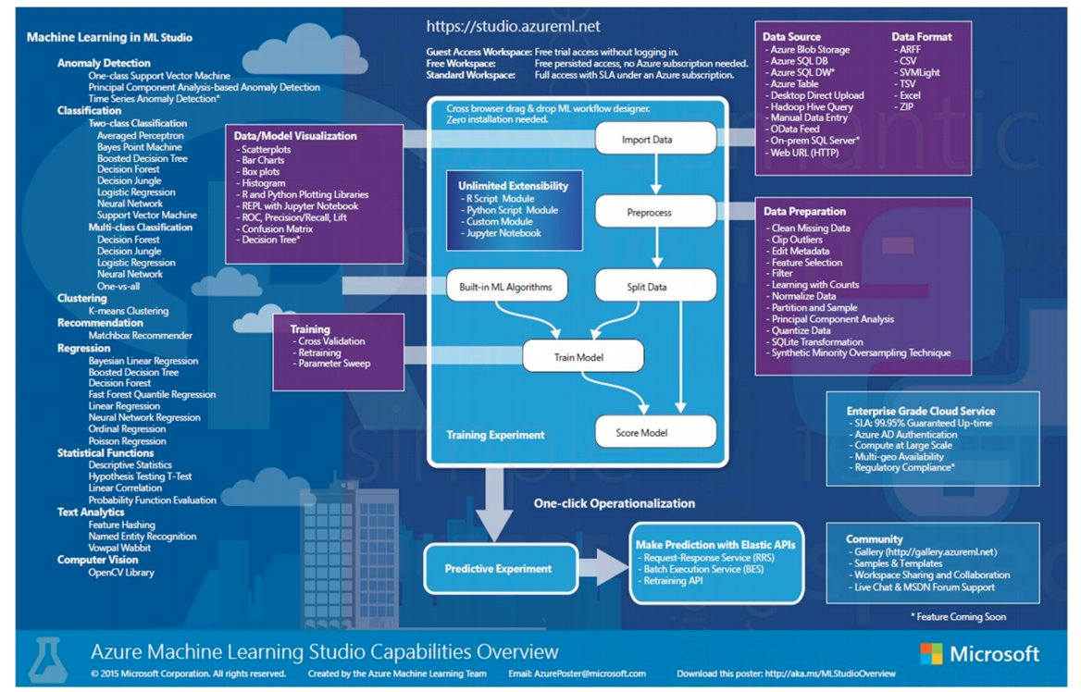

b. RStudio Programming Modules in AML (R Programming Language)

Machine Learning Studio (classic) contains many powerful machines learning and data manipulation modules. With the R programming language, this combination provides the scalability and ease of deployment of Machine Learning Studio (classic) with the flexibility and deep analytics of R

* Create code for data cleaning and transformation.
* Analyze the correlations between several of the variables in our dataset.
* Create a seasonal time series forecasting model for milk production.

1. Forecasting Model:

**Activity 1: Define the Analytical Architecture required for deploying this statistical model**

* Identified the statistical model that is used for this project and what steps need to follow is decided in this step.

Activity 2: Create R code for data cleaning and transformation.

* Read the caddairydatav3_shabana.csv file into Azure ML studio
* milkutilities-8_shabana. R file which is converted as zip file and read that file to Azure AML.
* After loading both files dragged to the experiment to develop algorithm
* This milkutilities.py file received with the requirements document which consists of functions to create a POSIXct time series and another function created to Function to trim the month codes to 3 characters to ensure they are consistent
* By using to. POSIXct (user defined) function Created time index column which is a new POSIXct column using R.
* After loading data into forecasting model, Included R language modules which is execute script model. In this execute script model I removed duplicate rows, removed 1 and 2 columns (s.no, Year. Month column). Deleted the rows which has NA values.
* Created columns with the polynomial values of Month. Number. To account the nonlinear trend created two columns contains the Month.CountSqred, Month.CountCubed. These values are calculated by squaring, cubing the month. Count column.
* After including all the steps in execute R script mode run the experiment and checked the results that new columns are added or not.

**Activity 3: Perform initial visualization of the California milk production data using R**

* In this activity I added one more execute R script mode to the model. In this R script again read the milkutilities-8_shabana. R file. And given the input data table for this execute R script as updated datable which includes Month.CountSqred, Month.CountCubed and MonthDate column.
* In execute R script file I Computed a linear model of the trend by using lm () function and added the predicted values to the data frame.
* In this file I plot the graph on actual date time values vs milk production.
* After calculating prediction values plotted line graph of prediction values on actual values graph.
* Checked the Correlation with R and pairwise plots

Activity 4: Usage of regular AML modules

* In this step I added Edit Metadata to the experiment. For this step I categorized month using edit metadata. First, I Launched the month column to the model from dataset and then under Categorical section changed it to Make categorical.
* Next, I choose Select columns in dataset mode and added it to the experiment. In this mode I selected Milk. Prod, Month.CountSquared, Month.CountCubed, Month. Count, Month, date Time columns.

Activity 5: Split the time series data using R

* In this step I added Execute R script mode to the model.
* In this execute R script mode I Read the milkutilities. R file to ensure the dataTime column is preserved.
* Later I eliminated the last one year (12 months) of the dairy data frame.

**Activity 6: Training and scoring data**

* Added the Linear Regression mode to the experiment and the output of Regression model to the Train model for Milk. prod. In the Train Model, launch column selector as Milk. prod column.
* Later add Score model.to the Score model give output of Train model and Edit Meta Data output to Score model as input.
* Add Evaluate model as a next step. Save the model and execute the model.

1. Setting up the Forecasting Model:

Loading caddairydatav3_shabana.csv file and milkutilities-8_shabana.R.Zip file to Azure Machine Learning Studio. multiutilities-8_shabana.R.zip file contains two functions that are

* Function to create a POSIXct time series
* Function to make Month column an ordered factor

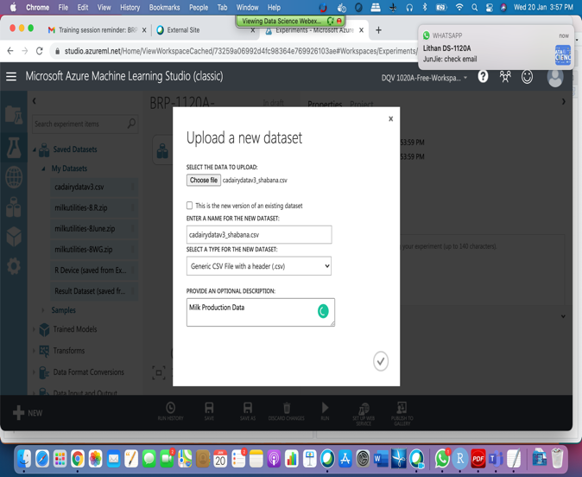 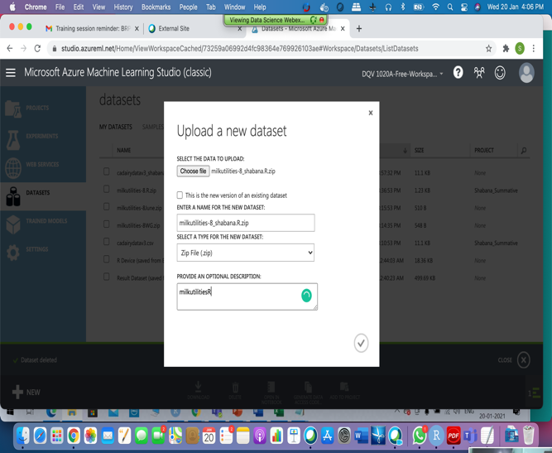



After adding data set and zip file to the model checking the dataset. The dataset caddairydatav3_shabana consists of 228 rows and 9 columns

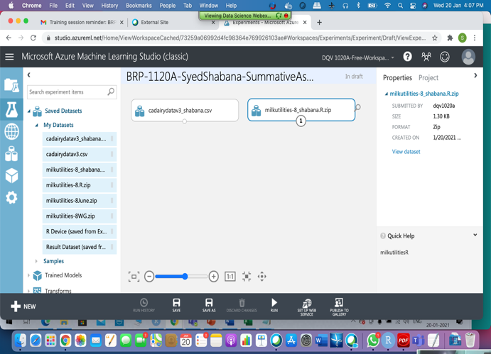 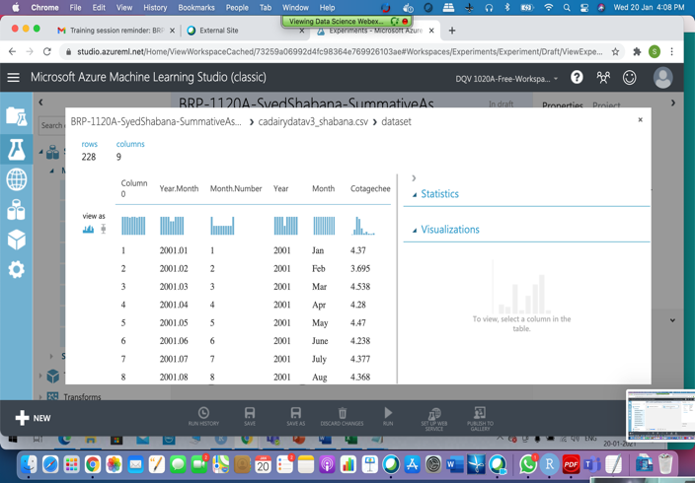

In this step added Execute R script to the model. In this execute R script

* Read the milkutilities-8_shabana.R file to the script.
* I wrote some code to delete 1 and 2 columns which are not useful for prediction
* Omitted NA’s
* Removed duplicate rows
* Trimmed the codes of column 'Month' to 3 characters like Jan, Feb
* Created a time index column which is named as ‘dateTime’ column
* Created columns with the polynomial values of Month.Number
* Created columns like Month.CountSqred, Month.CountCubed by using Month.Number column (which is ^2,^3)
* Saved the model and run the model. Executed successfully.
* Now check the result data set which consists of 228 rows and 11 columns.
* We can see the dataset that we received does not have any duplicates or NA. So same number of rows displayed. But 3 new columns added to the dataset.

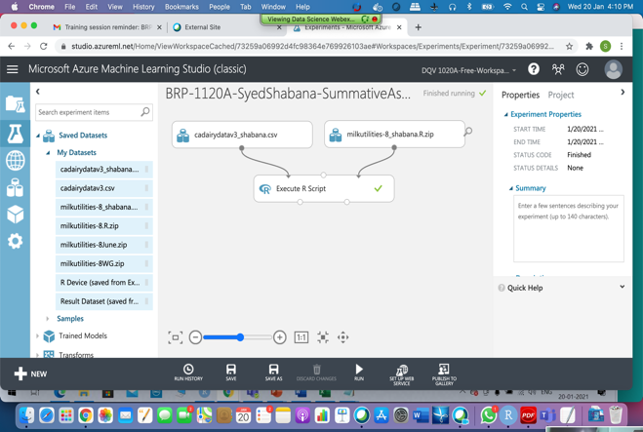 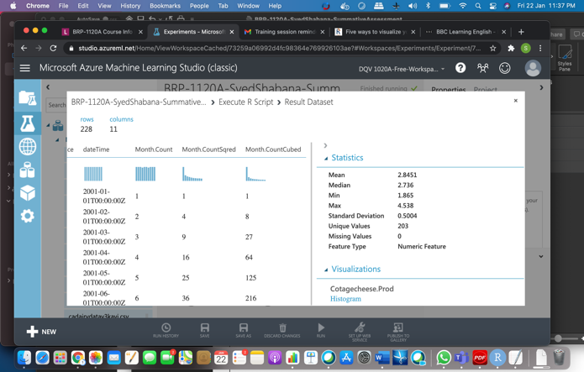

Now connected output of first Execute R script file to second execute R script file.

* In the second R script file I wrote some code for predicting milk production
* In this file first I read the milkutilities-8_shabana. R file
* Ensured the dataTime column is preserved
* I wrote some code to plot the line graph for Milk.Prod. How the milk production is changing based on datetime can be seen from this line graph
* Later I calculated the prediction value for milk production using linear regression model

and added the predicted values (Pred1) to the data frame.

* Plot the actual and predicted values of milk production using “ggplot” functions
* Plot non-linear (^3) trend model (added as a layer on raw model) for milk production
* From the below screen we can see pred1 column is added to the dataset. Now total rows 228 and 12 columns we have after the script execution.

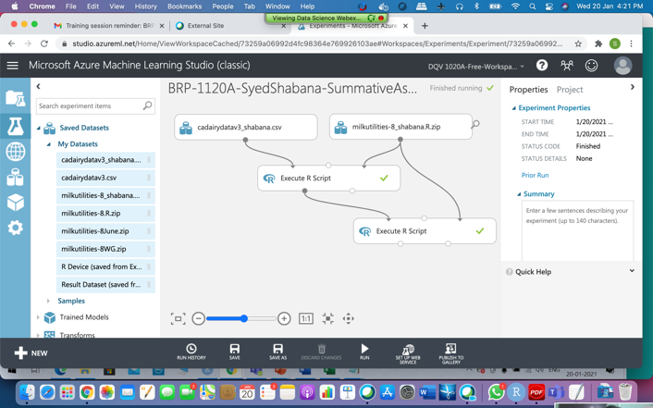 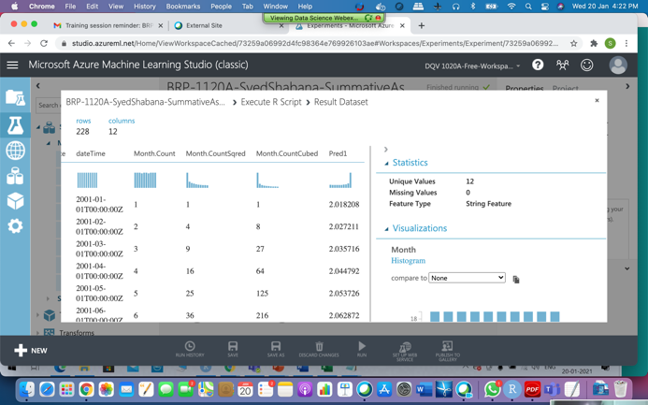

Here the first graph is from the actual raw data and the second graph shows the non-linear (^3) trend model which drawn with predicted values. The blue line in the second graph shows the linear regression value without polynomial values.

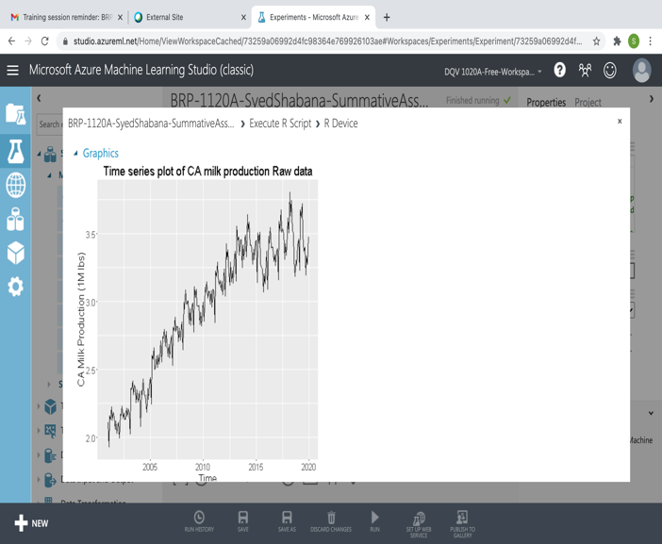 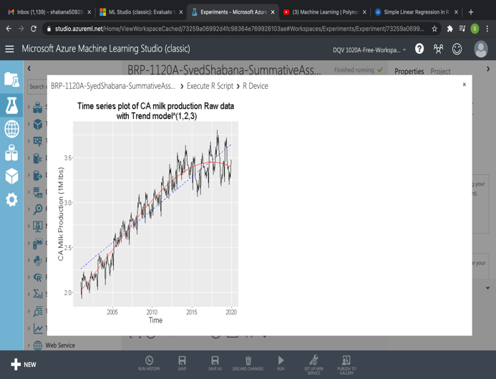

In this step added Edit Metadata to the model. The output of first execute is given to Edit Metadata. In this step I selected the month column and changed month column to categorical.

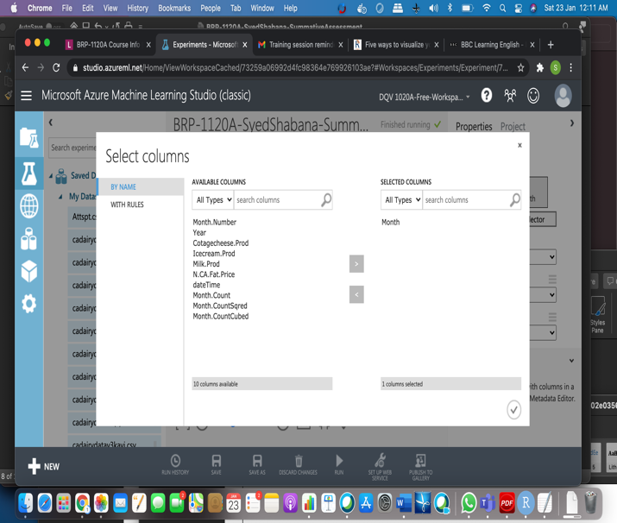 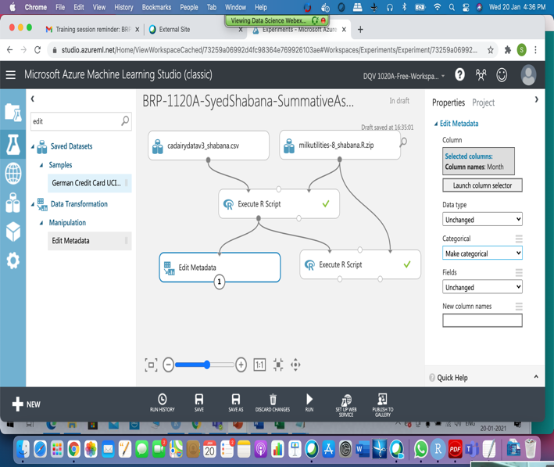

In this step I added select Column in dataset to the model. The output of Edit Metadata is given to Select Column in Dataset. Here I selected Milk_Prod, Month.CountSqred, Month.CountCubed, Month.Count columns.

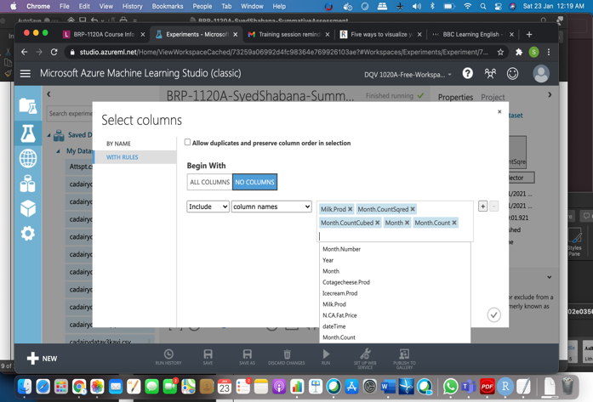 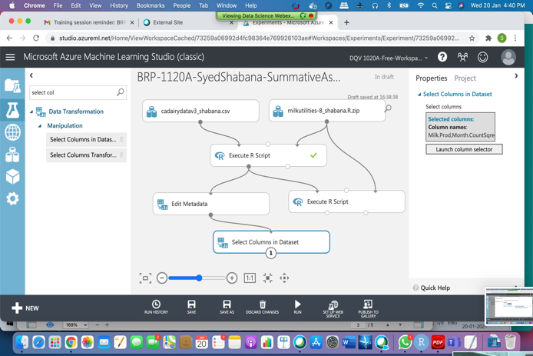

After Successfully saved and run the model I can see my resulting dataset. Here my result dataset consists of 228 rows and 5 columns. We have 5 columns because we selected 5 columns in this step.

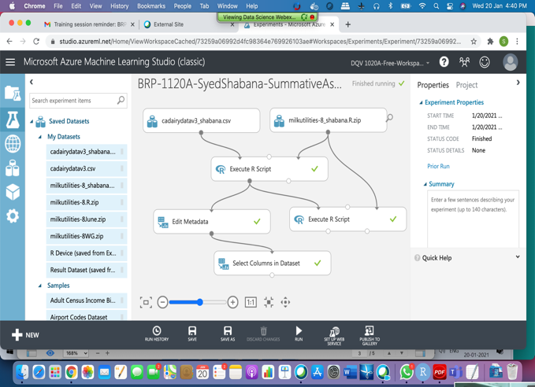 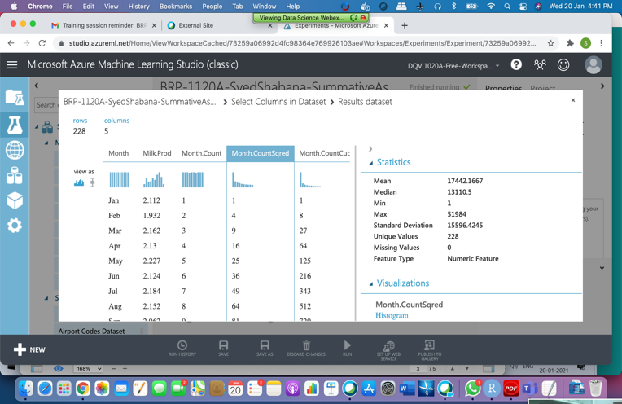

In this step I added ExecuteR Script to the model.

* Read the milkutilities-8_shabana. R to the script.
* Eliminated the last one year (12 months) of the dairy data frame in this script as per requirement document. Now the resulting dataset consists of 216 rows and 5 columns.

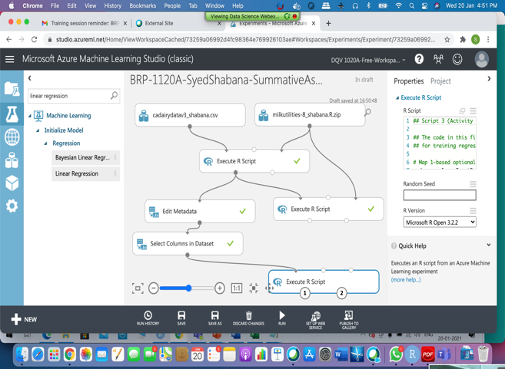 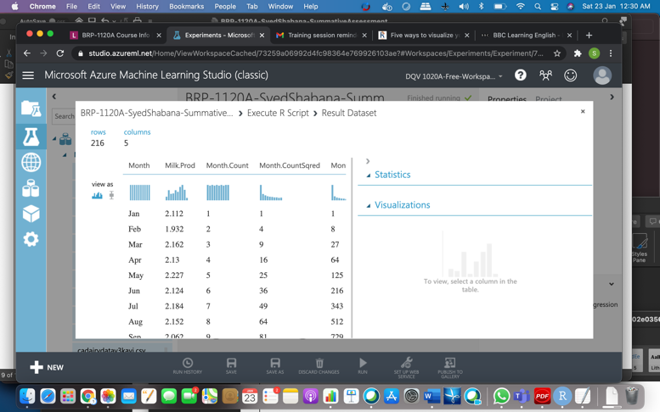

* Here I added Linear regression to the model.
* Next Added Train Model. In this step I given Linear Regression output to Train model as input and 3rd Execute R Script output also given to Train model for prediction.
* In this step I selected Milk_Prod column for prediction.

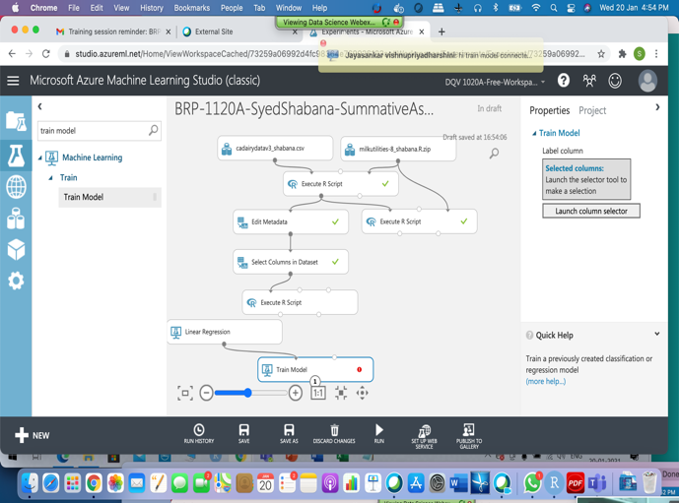 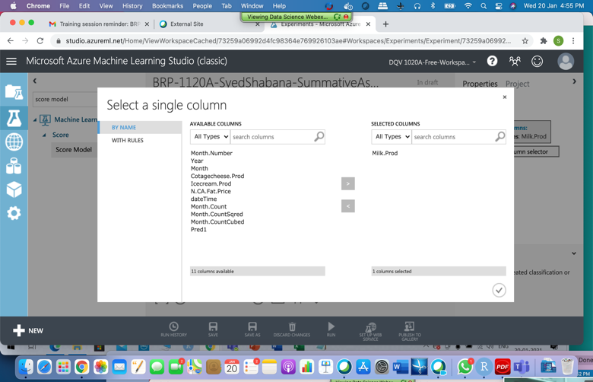

* Later added Score model to the model.
* Given Train Model output and Edit Meta data output as input to the Score Model.
* Next Evaluated the model by adding Evaluate Mode.
* After successful execution of the model. We can see the scored dataset consists of 228 rows and 12 columns.

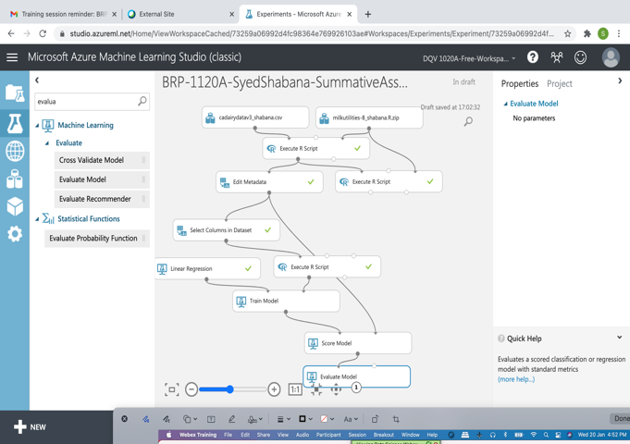 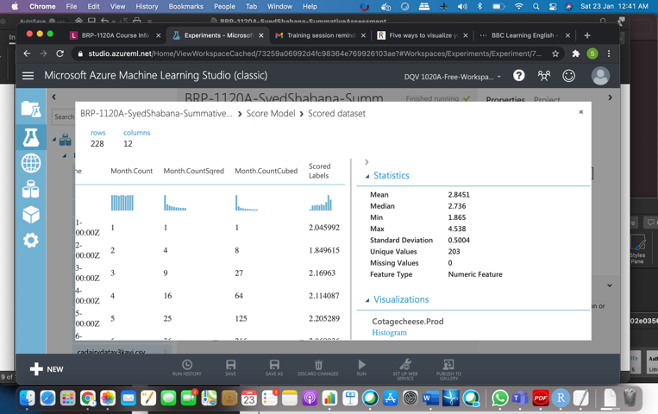

* In this step I added edit meta data to the experiment. I gave score model output as input to edit meta data.
* In edit metadata I selected ScoredLabels column for prediction in the next step execution R script.
* Next added execute R script to the experiment.
* The output of edit meta data and milkutility file has been connected to execute R script as input.
* In execute R script file we are plotting the actual and predicted values of milk production using “ggplot” functions.
* Plotted a non-linear (^3) Seasonal model (added as a layer on raw model) for milk production.
* Plotted time series plot of the residuals for Seasonal model
* Plotted histogram for the Residuals
* Computed Mean Absolute Error, Root Mean Squared Error, Coef of Determination

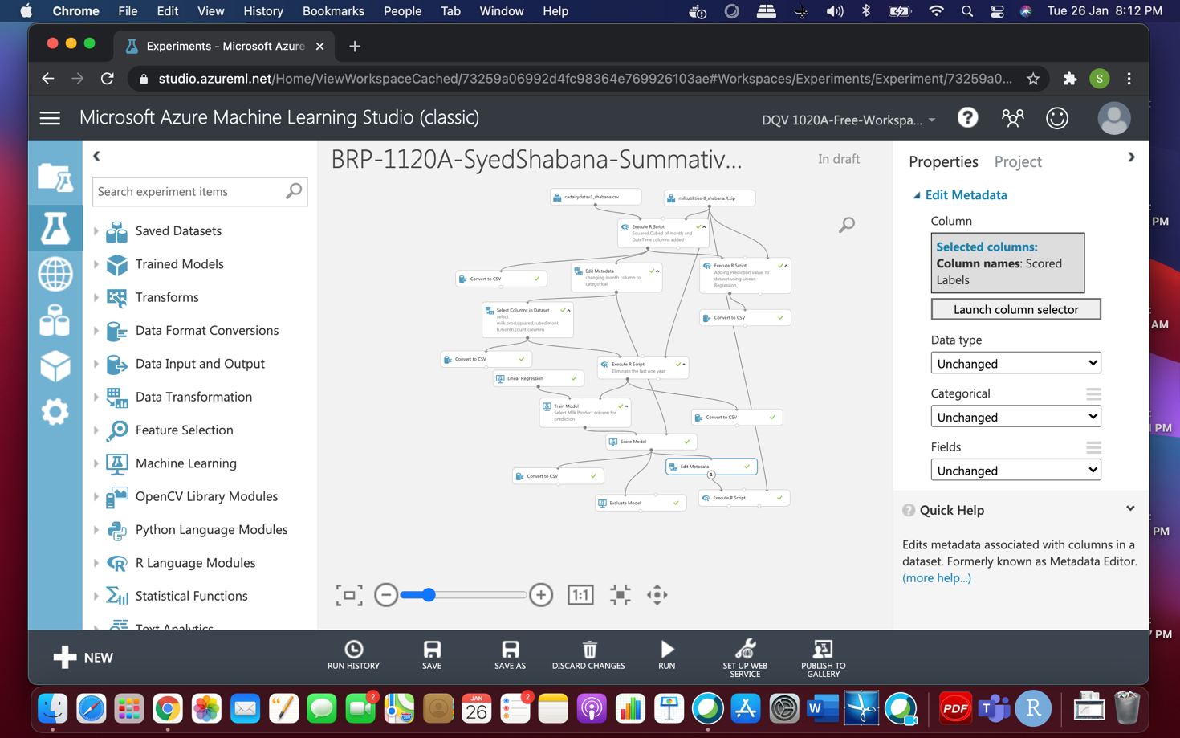

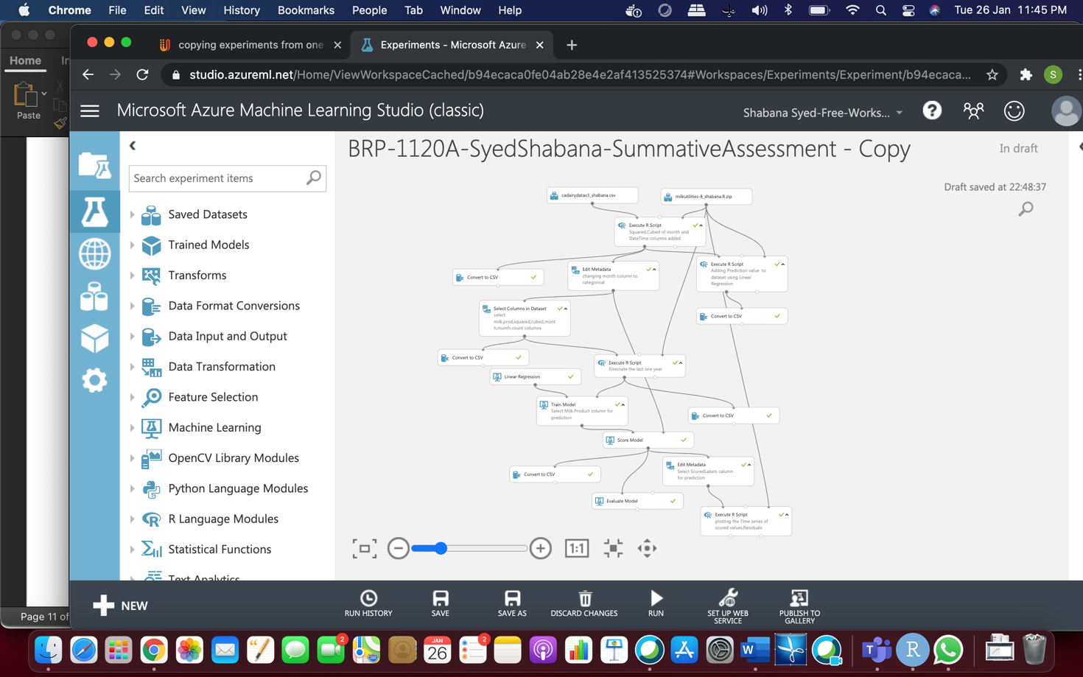

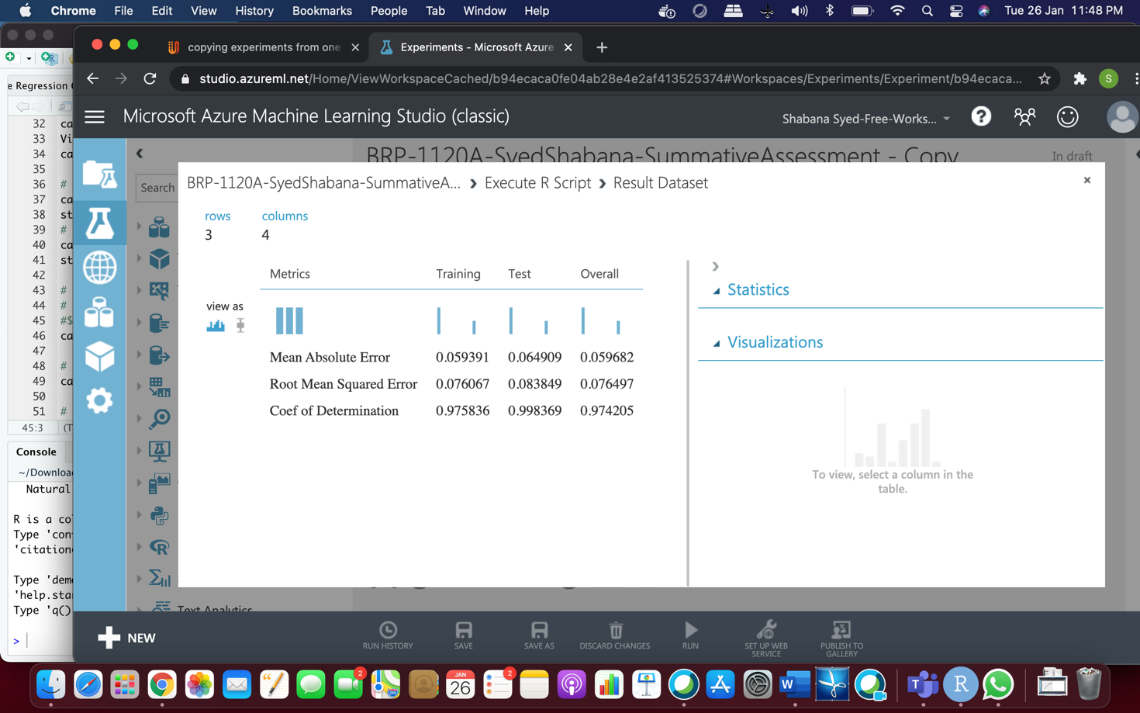

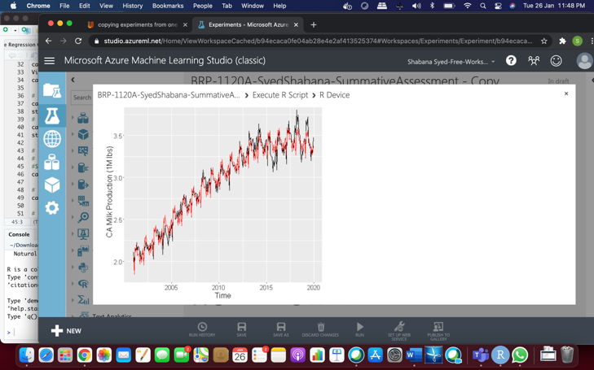 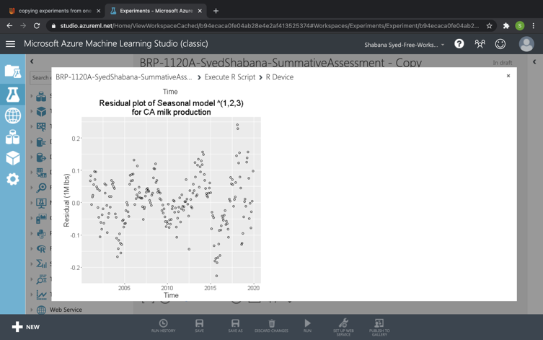

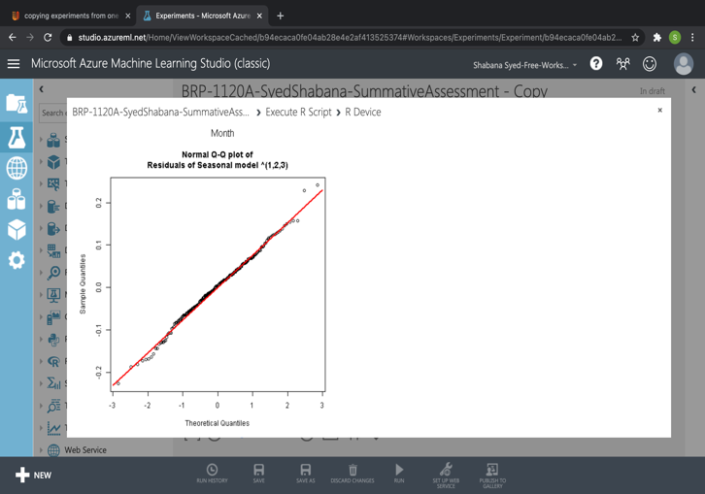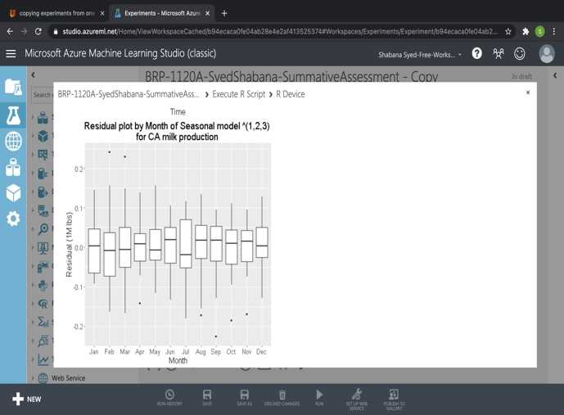

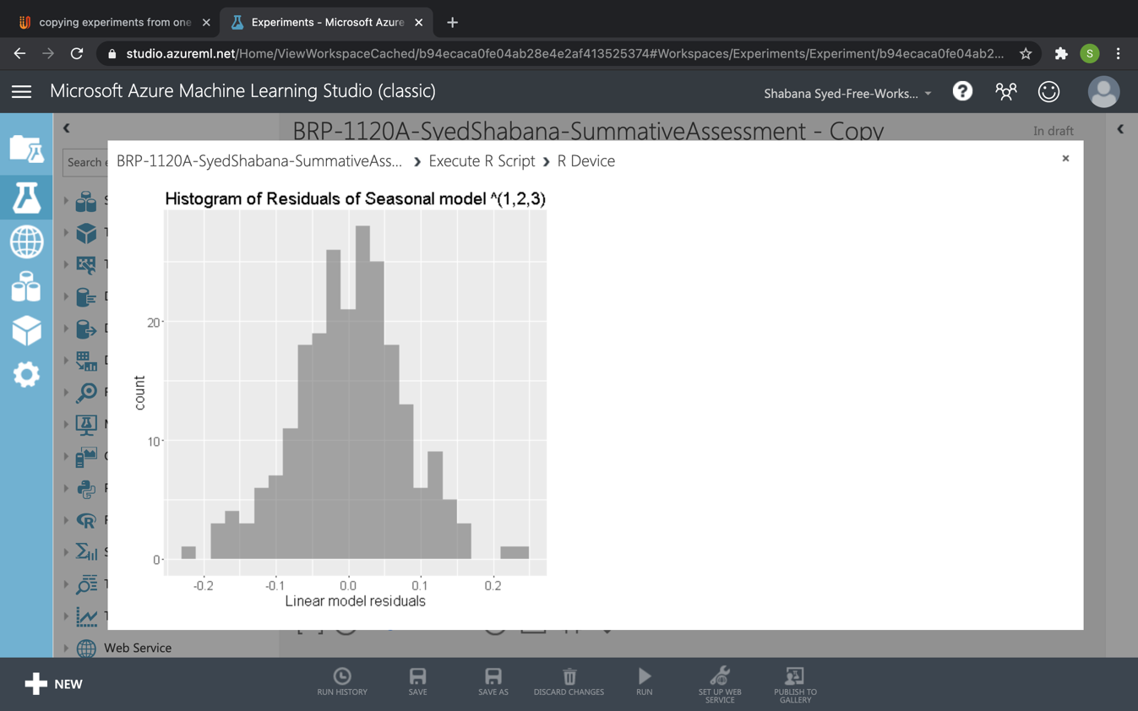

Here after evaluation of the experiment we can see the metrics.

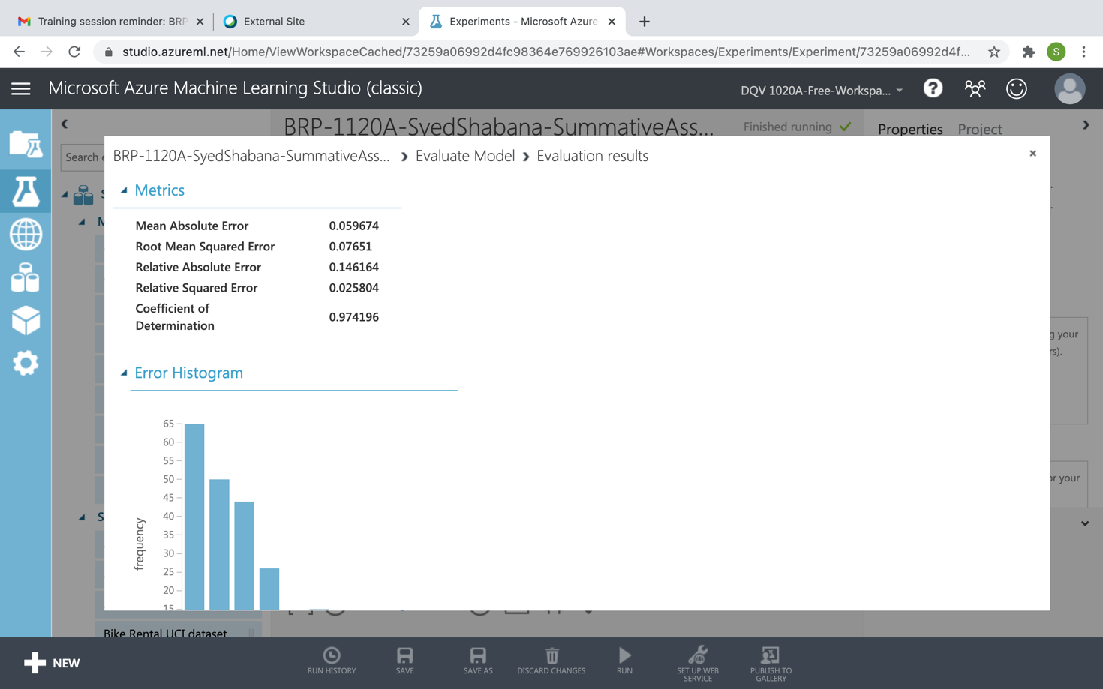

1. R Code / Python code for Data Filtering and Transformation: (Attach the R Code used in the Project for Data Transformation)

* In the first execute R file read the milkutilities file
* If any duplicate rows are there, removed those duplicate rows
* Removed two columns we do not need
* If any rows have NA values deleted those rows.
* Month column values were trimmed to 3 characters like Jan, Feb.
* Created a time index column with 'dateTime' name
* Created columns with the polynomial values of Month.Number up to the power of 3 like Month.Count, Month.CountSqred, Month.CountCubed.

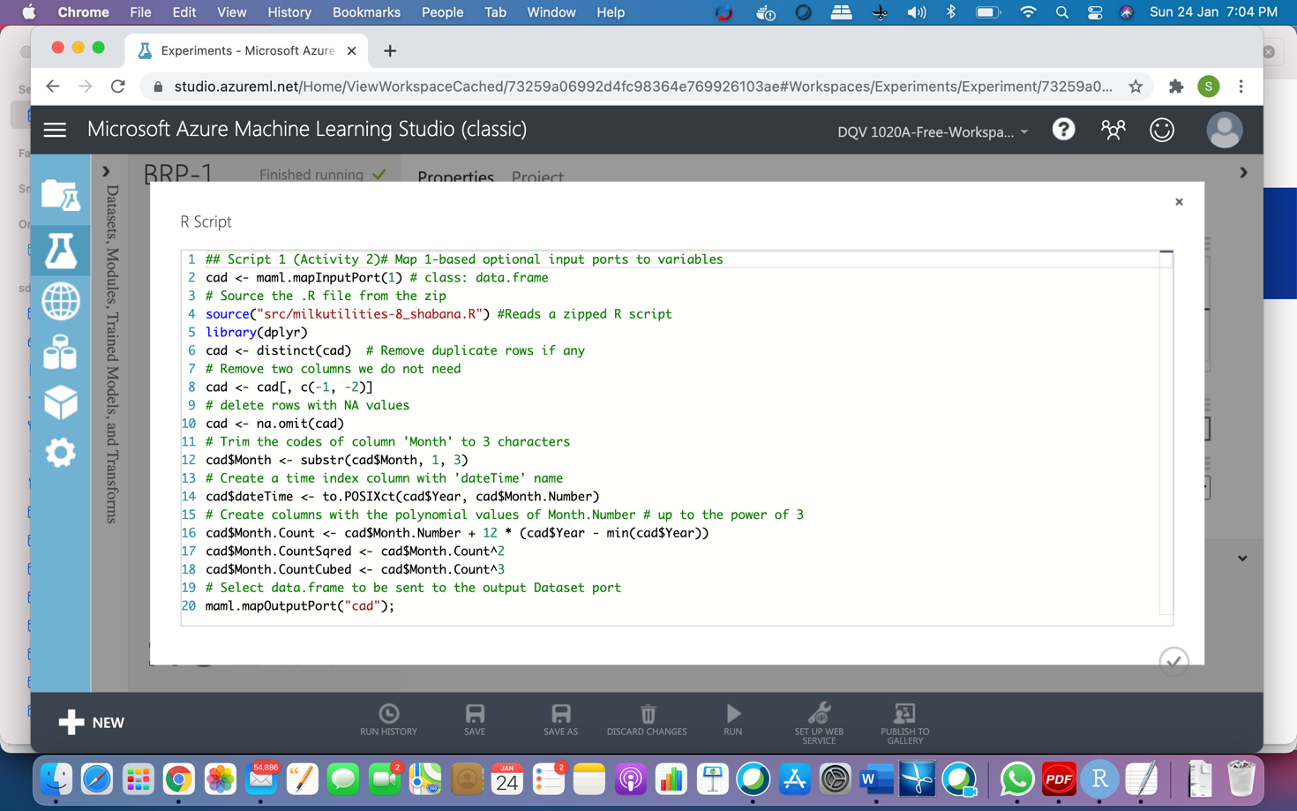

* In the first execute R file read the milkutilities file.
* Ensure the dataTime column is preserved.
* Plotted actual values (raw data) for milk production
* Plotted for linear ^1 trend line and for linear ^3 trend model for MilkPredict

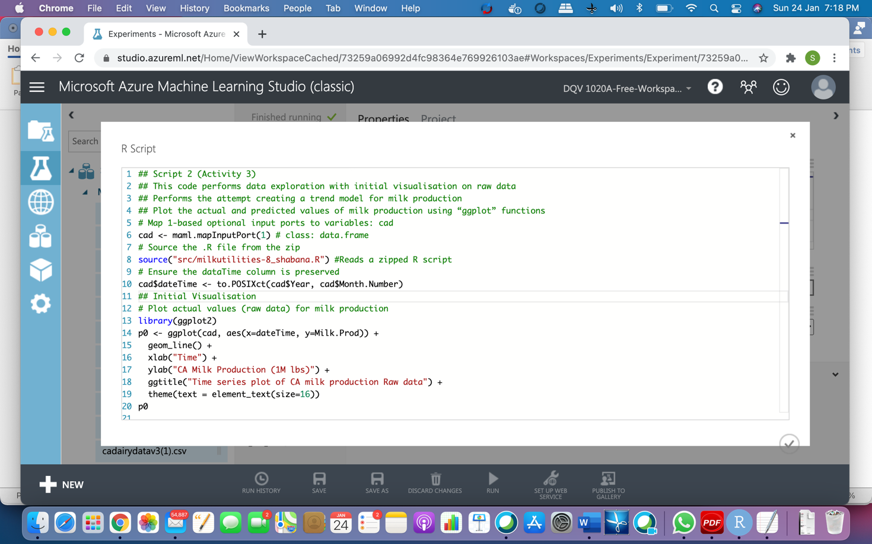

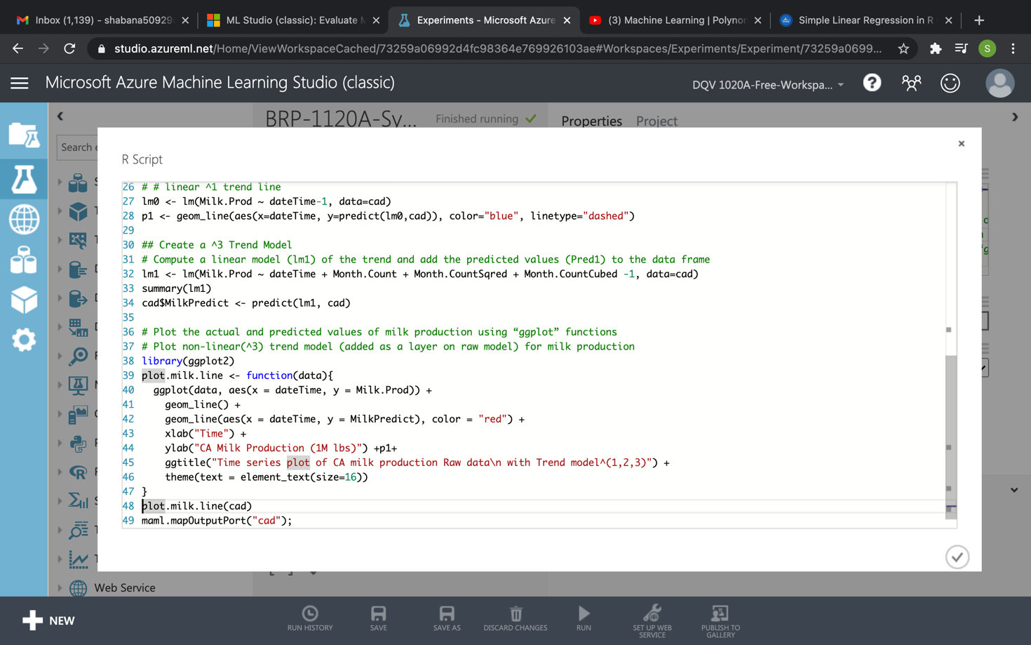

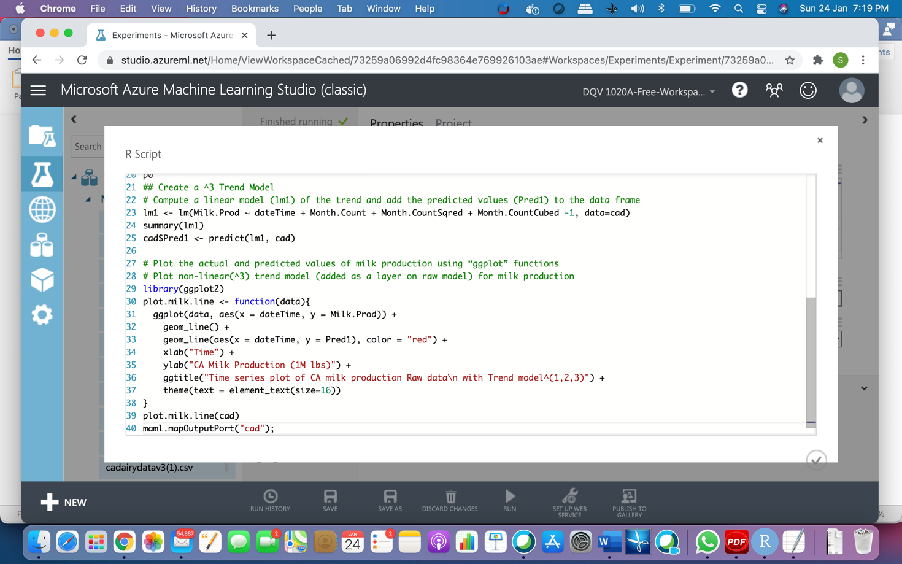

Eliminated the last one year (12 months) of the dairy data frame.

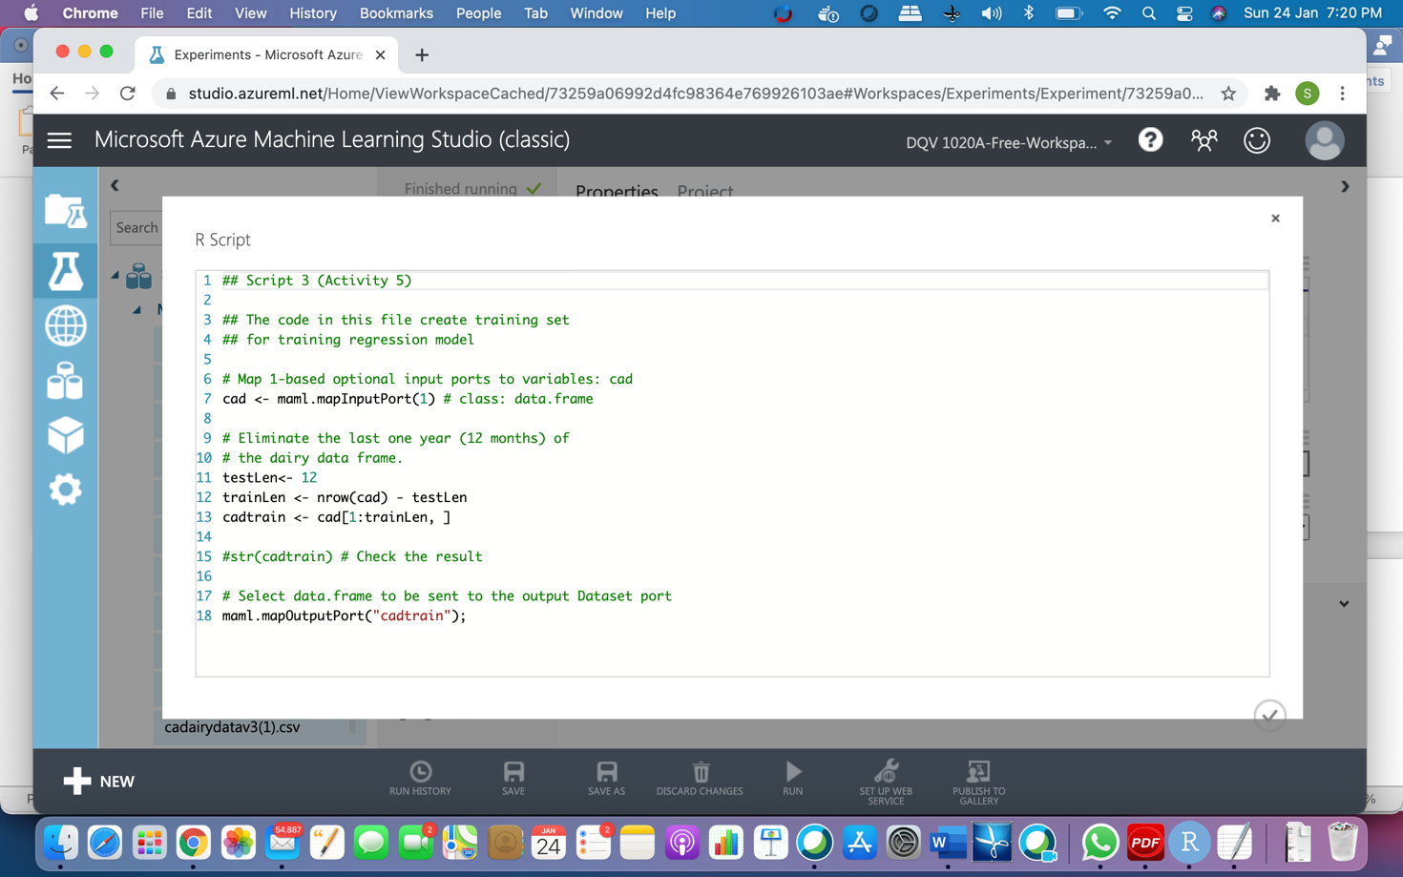

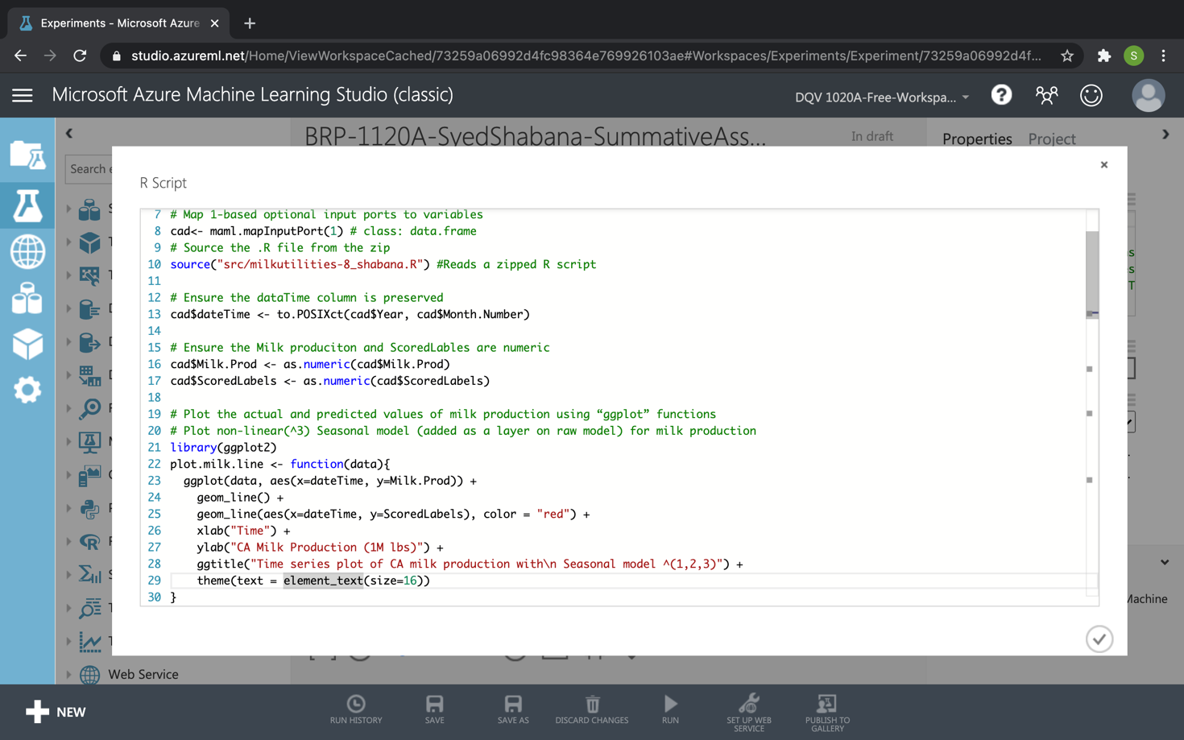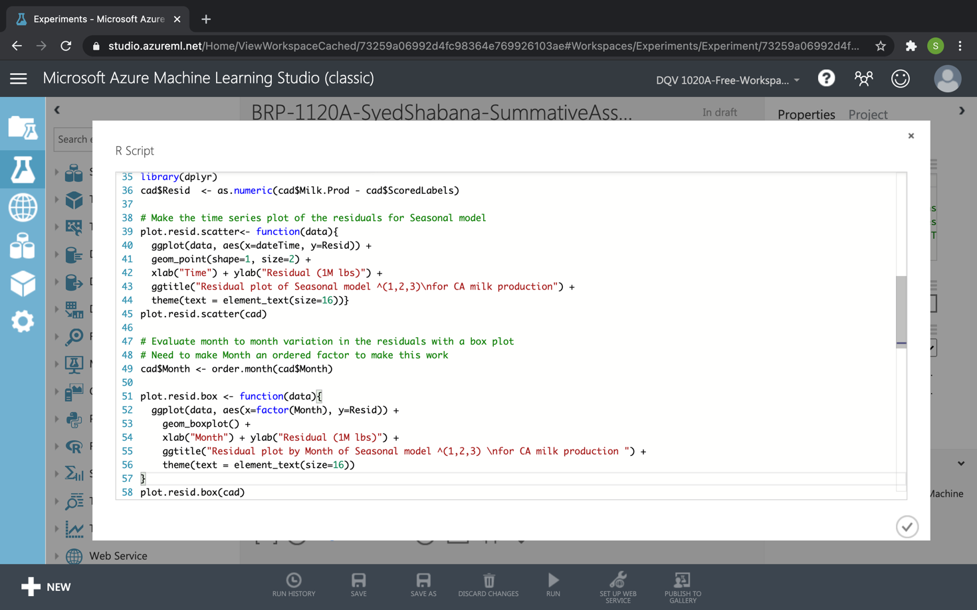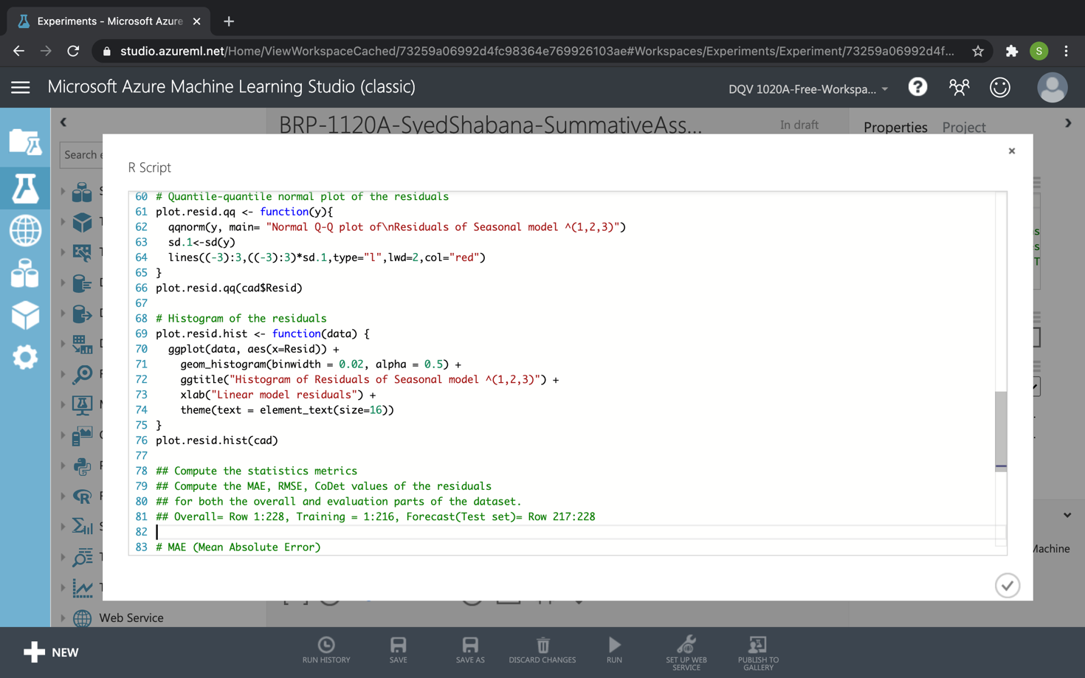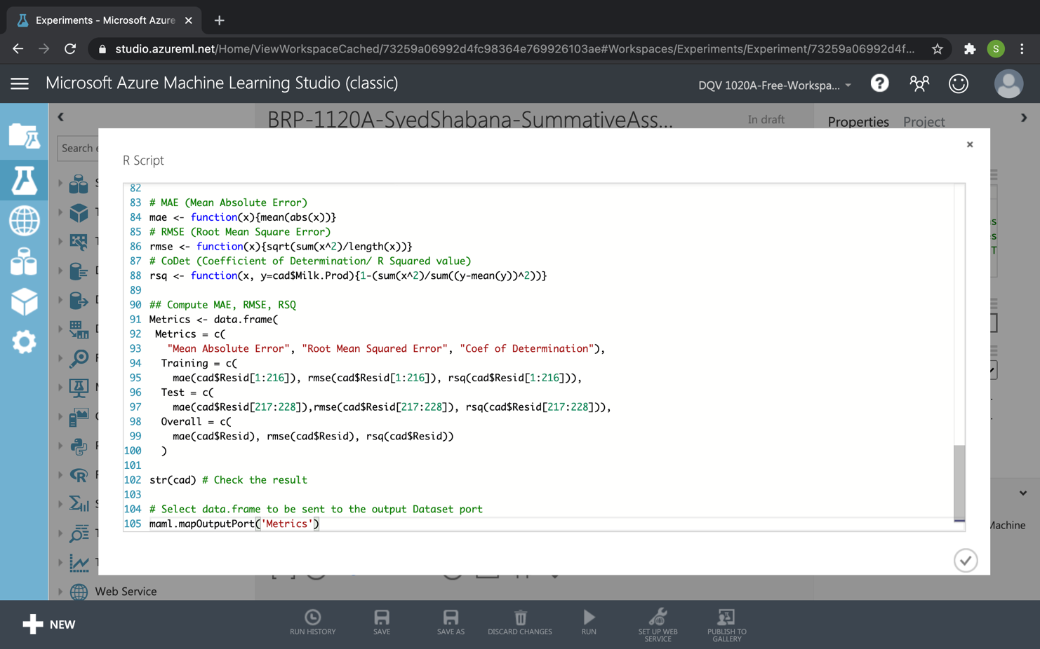

1. Visualized Data: (Attach the transformed data as Annexure)

1. Training dataset: (Explain how you performed the script3 along with the output as Annexure) (script 3 output)

1. Implementing script 4: (Explain how you have evaluated the Seasonal Forecasting Model) script 4
2. Refine Model: (Explain how you have refined the model along with Input, Process and Output)
3. Annexure 1
   1. Script1
4. Annexure 2
   1. Script 2
5. Annexure 3
   1. Script 3
6. Annexure 4
   1. Script 4
7. Forecast Output after Model Adjustment: (Explain the Forecast Output after you have adjusted the model based on actual production data